# GOVERNMENT COLLEGE OF ENGINEERING [IRTT]

**ERODE: 638 316**



# Electronics and Communication Engineering

**NAAN MUDHALVAN DIGITAL MARKETING ASSIGNMENT**

**NAME : HASAN SHERIFF A**

**BRAND NAME: DECOR DELIGHT**

**CATEGORY: INTERIOR DESIGN**

**NAAN MUDHALVAN ID: CD5B4C925F6FCE3B7204211EFF8AD230**

1. Create a blog or website using Blogspot and WordPress. Customize the theme design and post new article with 500 words.

Link: Blog using Blogspot

<https://decordelightinteriors.blogspot.com/2023/08/embracing-minimalism-elevate-your-space.html>

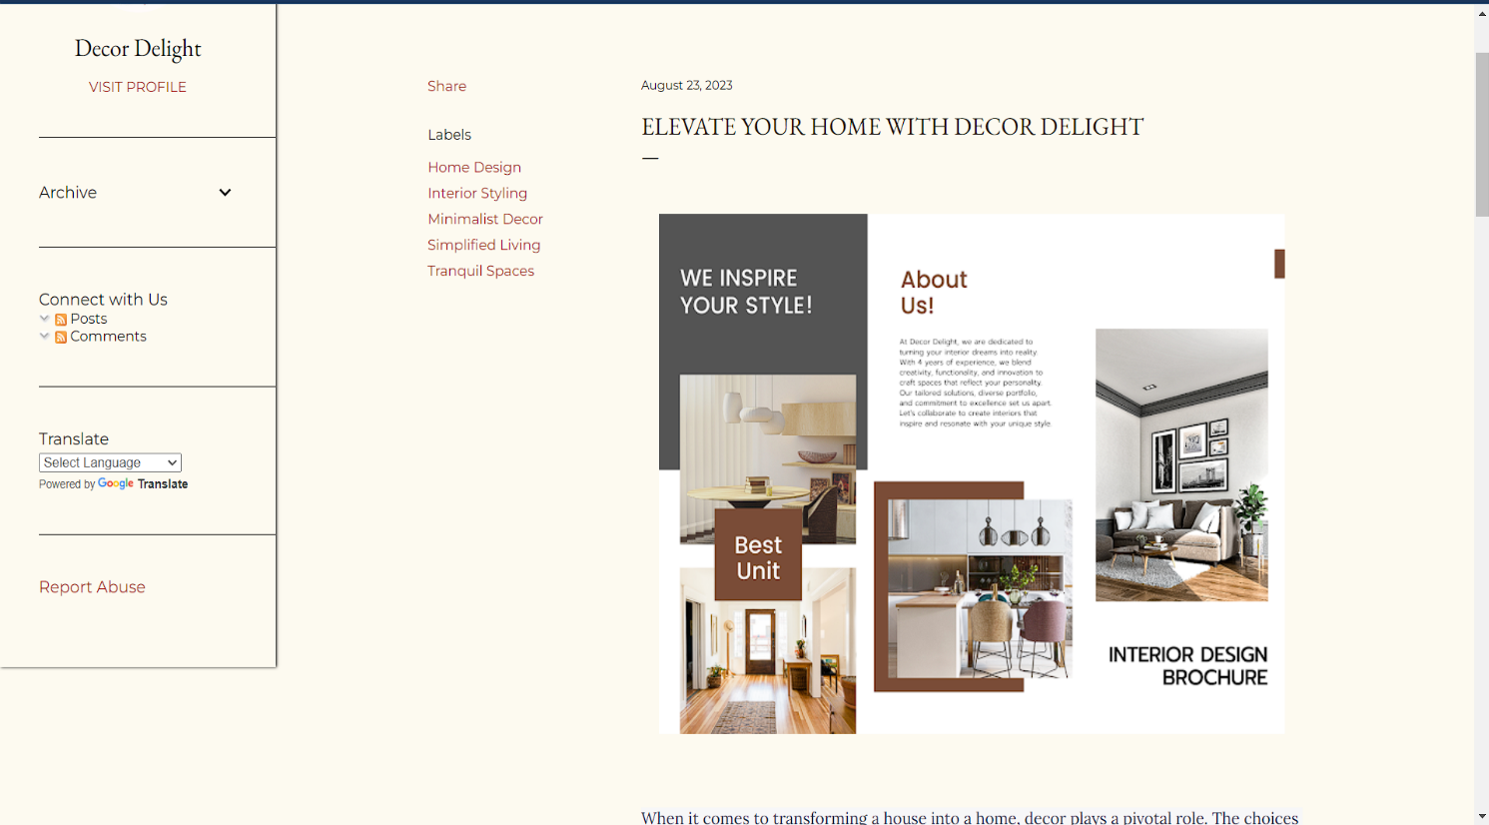Screenshot:

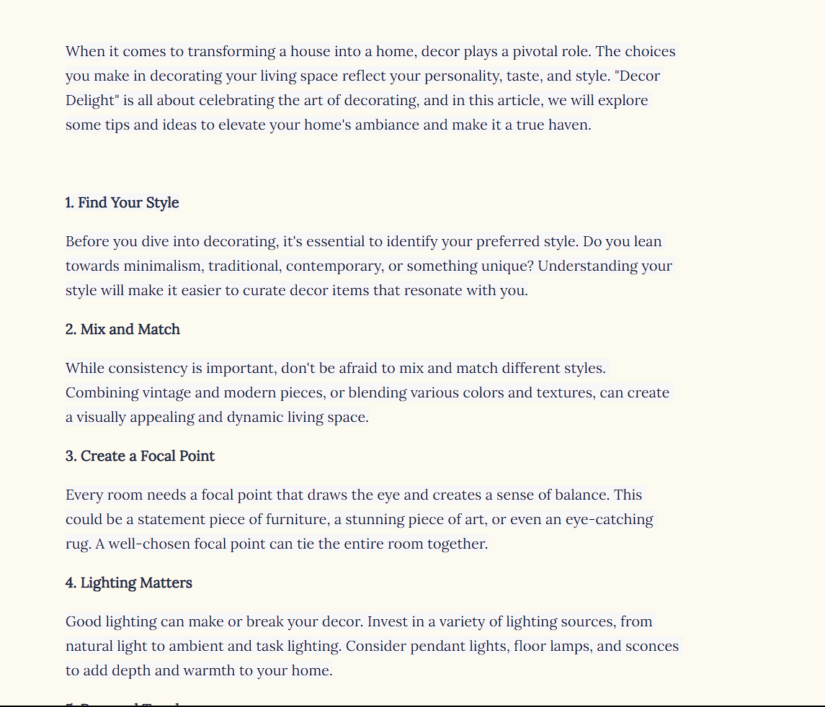

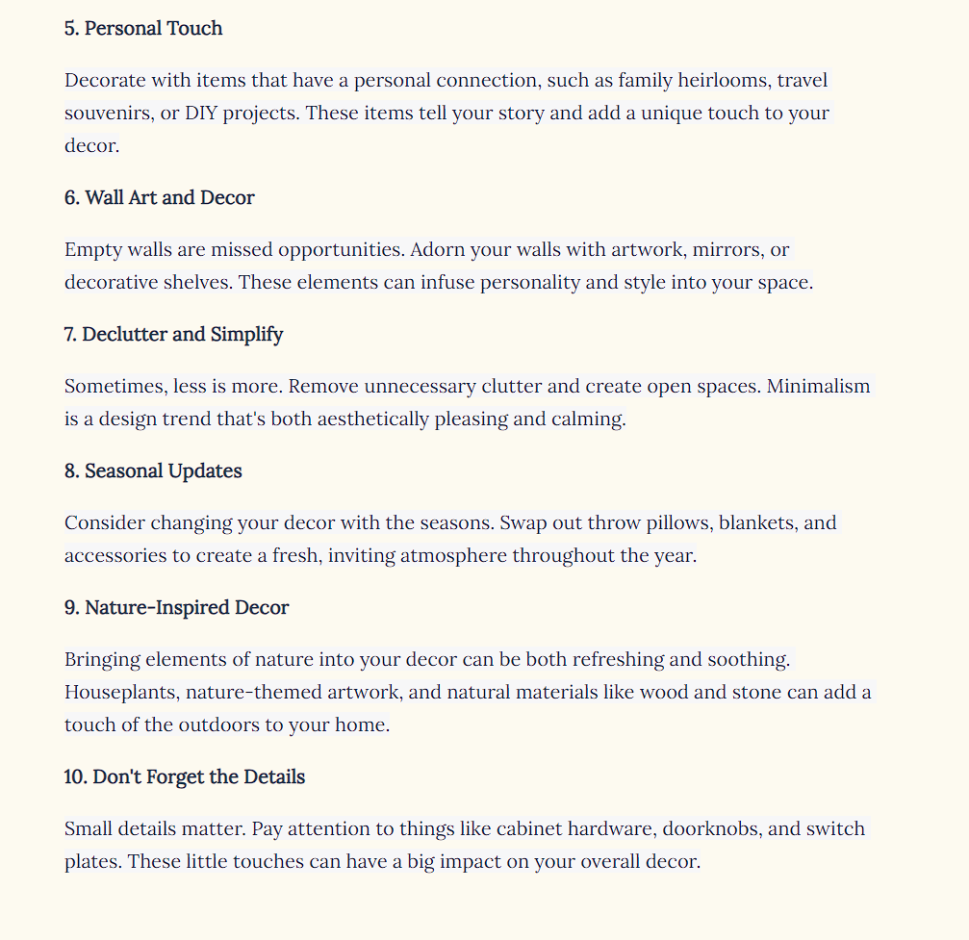

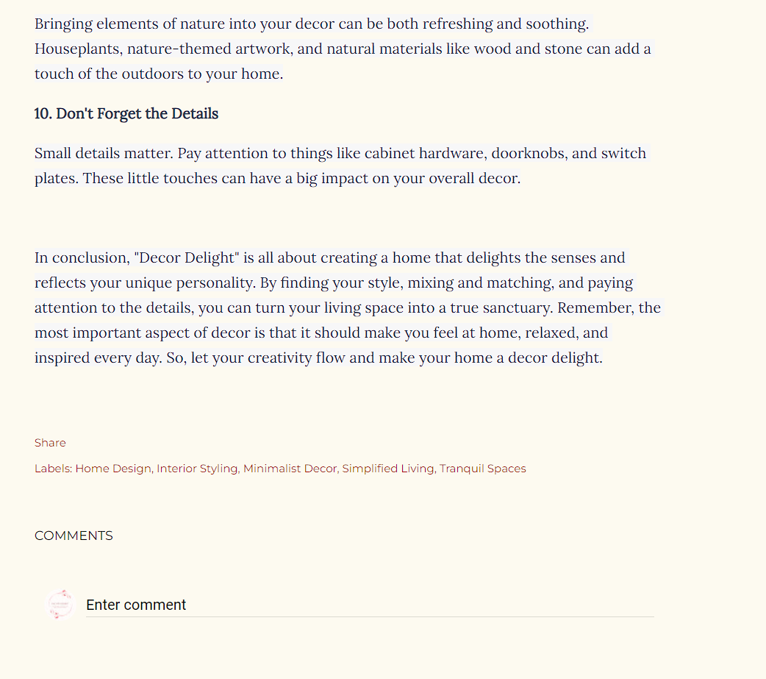

2.Create a New Facebook Business Page and post one social media poster for your brand.

Link: Facebook business page <https://www.facebook.com/profile.php?id=61550464239994>

Screen shot:

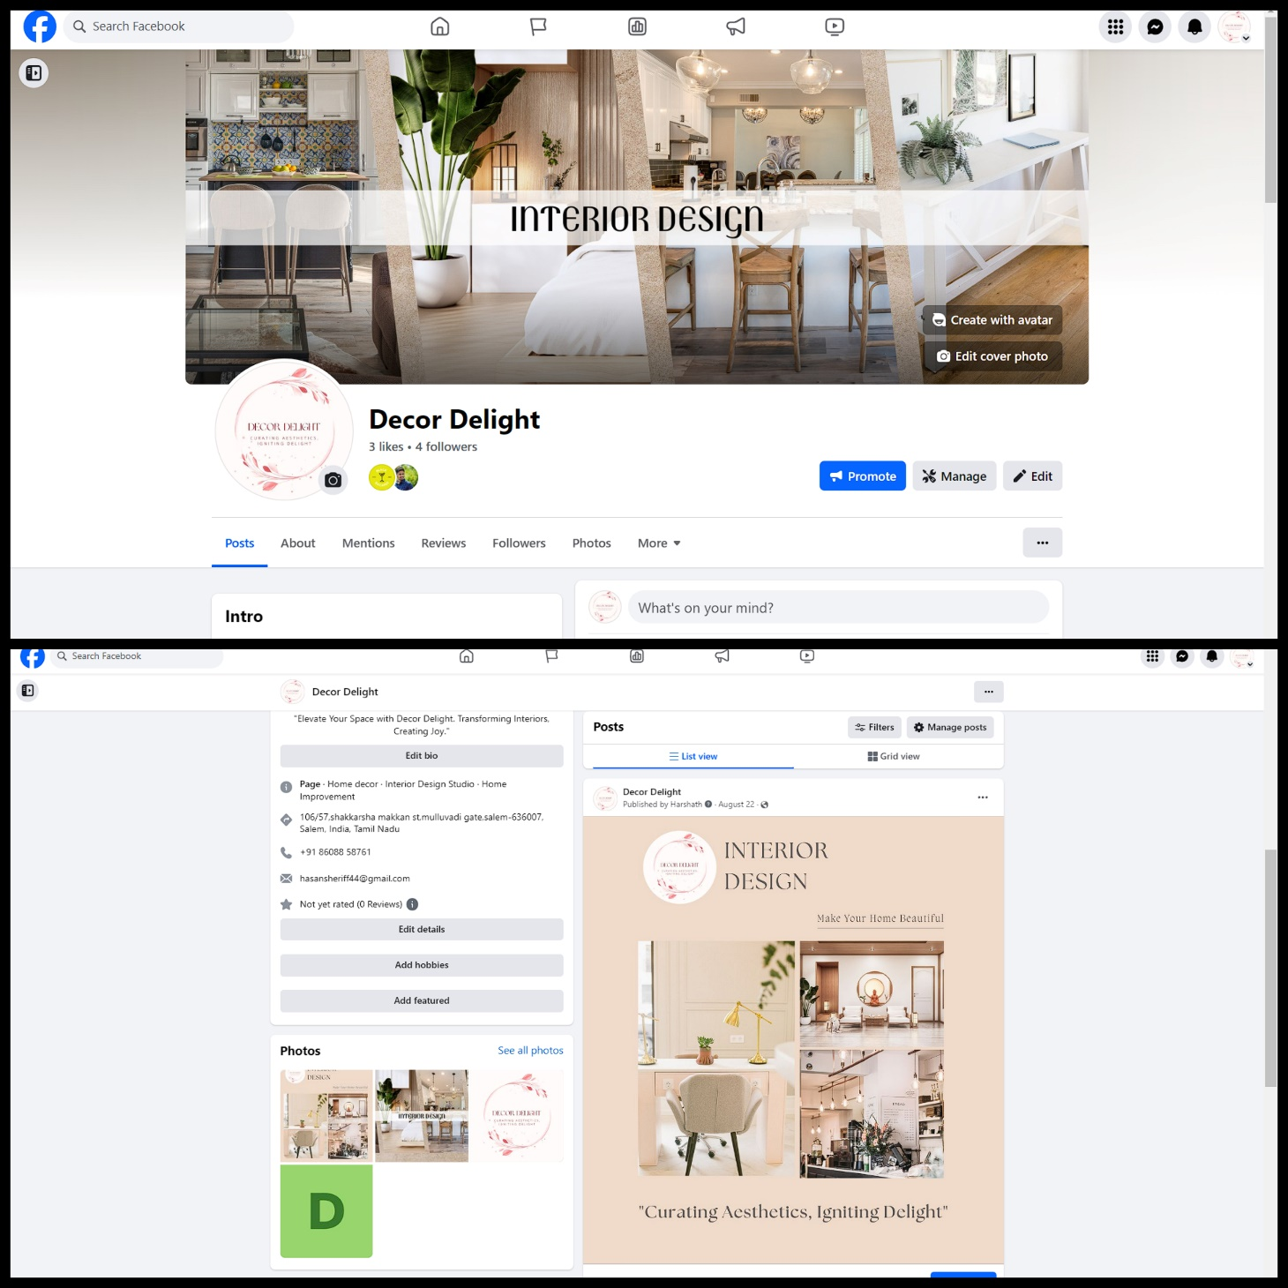

3.Create and design a social media advertisement poster using canva.

Link: Social media advertisement using canva

<https://decordelightinteriors.blogspot.com/2023/09/interior-design-secrets-unwrapped.html>

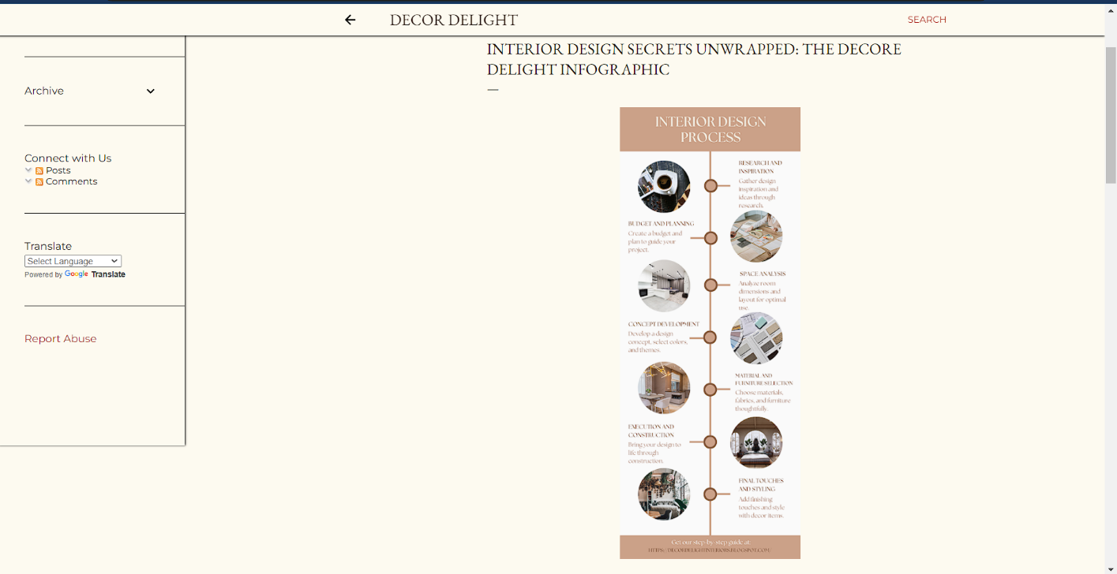

Screenshot:

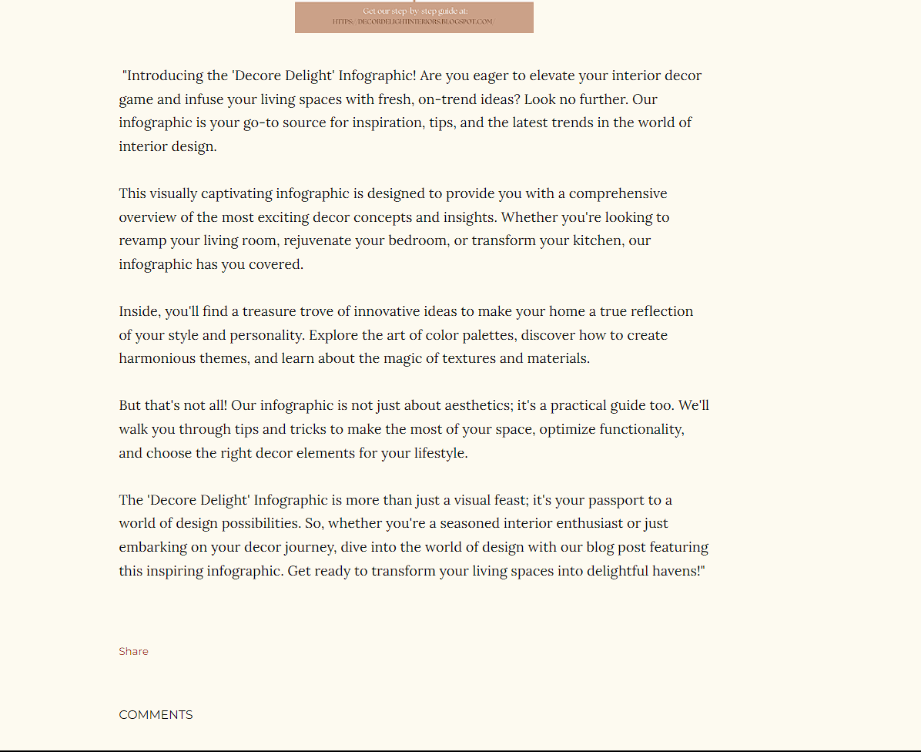

4.Create email newsletter design using MailChimp or canva tool.

Link: Email newsletter design using canva

<https://mailchi.mp/057b32033139/50-off-everything-at-decor-delight-15095938>

Screenshot:

